**Question 1**

**Launching an EC2 Instance:**

* Log in to the AWS Management Console.
* Navigate to the EC2 dashboard.
* Click "Launch Instance" and choose an Amazon Machine Image (AMI).
* Select the instance type and configure other settings as needed.
* Click "Launch" to create the instance

See the screenshot below for the above explanation

**Launch instances**

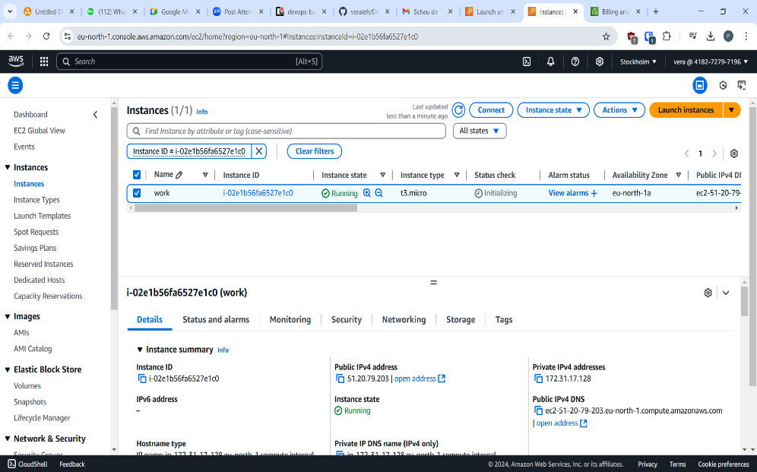

**Explanation using draw.io**

**Question 2**

**Attach a Security Group with Your IP as Inbound Rule to Port 22**

1. Go to the EC2 dashboard and select "Security Groups" from the sidebar.

2. Click "Create security group" and give it a name and description.

3. In the "Inbound rules" tab, click "Edit" and then "Add rule".

4. Select "SSH" as the protocol and enter your IP address in the "Source" field.

5. Click "Save" to apply the changes.

6. Associate the security group with your EC2 instance.

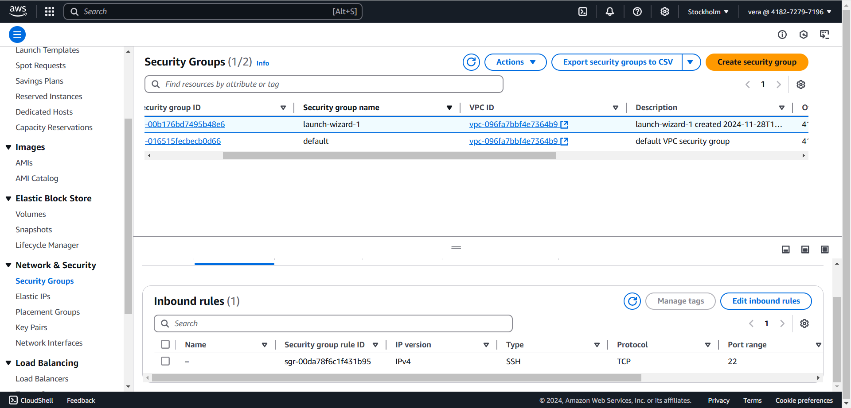

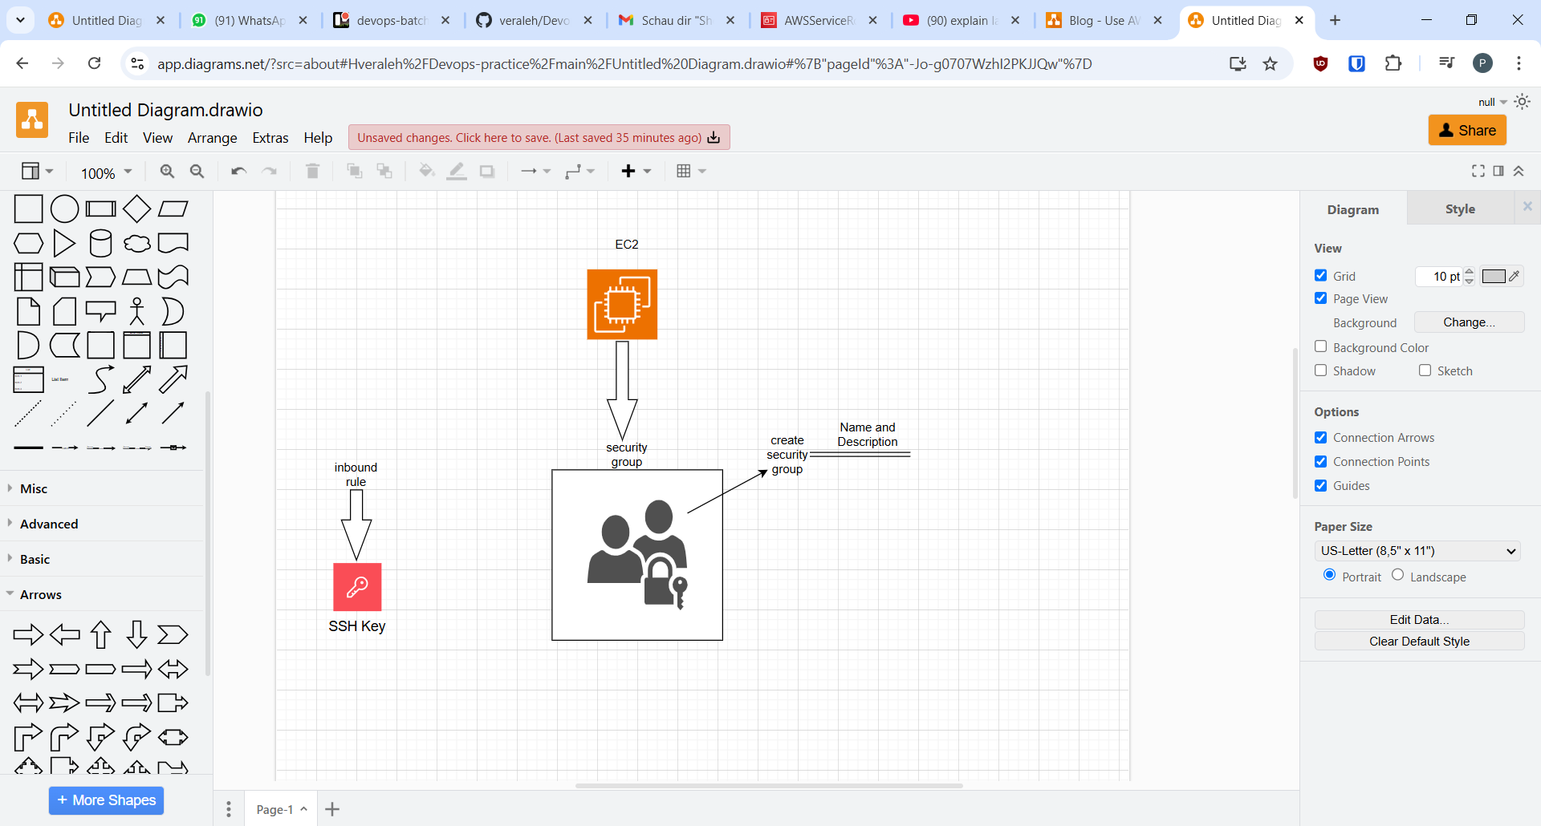

**Question 3**

**Describe the Key Pair Purpose**

A key pair is a set of security credentials that you use to connect to your EC2 instance. The key pair consists of:

**- A private key:** used to connect to your instance.

- **A public key:** stored on your instance and used to authenticate your connection.

When you launch an EC2 instance, you can choose to create a new key pair or use an existing one. The key pair is used to secure your connection to the instance.

**Question 4**

**How to Modify the Role**

To modify a role in AWS:

1. Go to the IAM dashboard.

2. Click "Roles" in the sidebar.

3. Find the role you want to modify and click on its name.

4. Click the "Edit" button next to the role's name.

5. Make the necessary changes, such as adding or removing permissions.

6. Click "Save changes" to apply the modifications.

See diagram below

**Question 5**

**Attach the Inline Policy to the Role**

To attach an inline policy to a role:

1. Go to the IAM dashboard.

2. Click "Roles" in the sidebar.

3. Find the role you want to modify and click on its name.

4. Click the "Permissions" tab.

5. Click the "Add permissions" button.

6. Select "Create inline policy" and choose the policy type (e.g., "Custom policy").

7. Enter the policy document and click "Review policy".

8. Name the policy and click "Create policy".

9. The inline policy is now attached to the role.

See the figure below

